

**Computational Finance with C++**

**Individual Coursework**

**CID: 01267314**

**King Hang Wong**

**Software Structure:**

In this project, I created three different classes, including Portfolio, matrixOperations and statisticalOperations. The diagram below shows the relationship between 3 classes

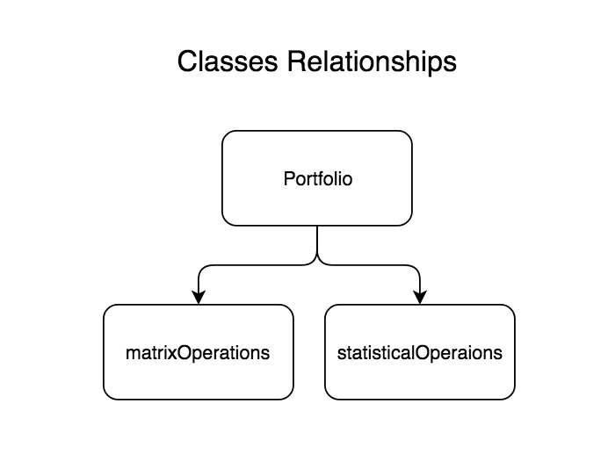

Therefore, the portfolio class will only call the functions inside matrixOperations and statisticalOperations, but not the other way round. For example, inside the optimization process, we called the static matrix multiplication function inside matrixOpertaion class in order to perform the matrix multiplication.

**Processes:**

At the beginning of the project, I started reading the return data by using the code provided. It returns a 2 dimensional array of 700 days return with 83 companies. Then I transform this array into a 2D vector in order to make the code consistent by using vectors. After that, I created in sample and out of sample matrices, which are both 3D vectors. These two matrices look like the following:

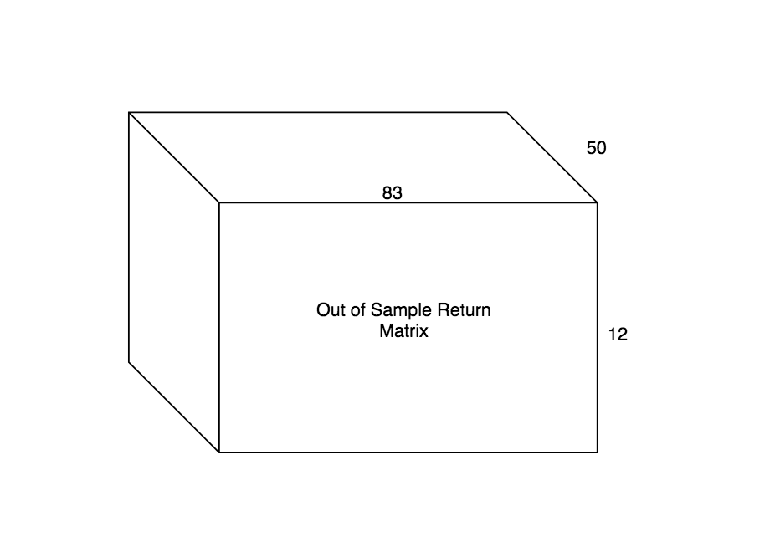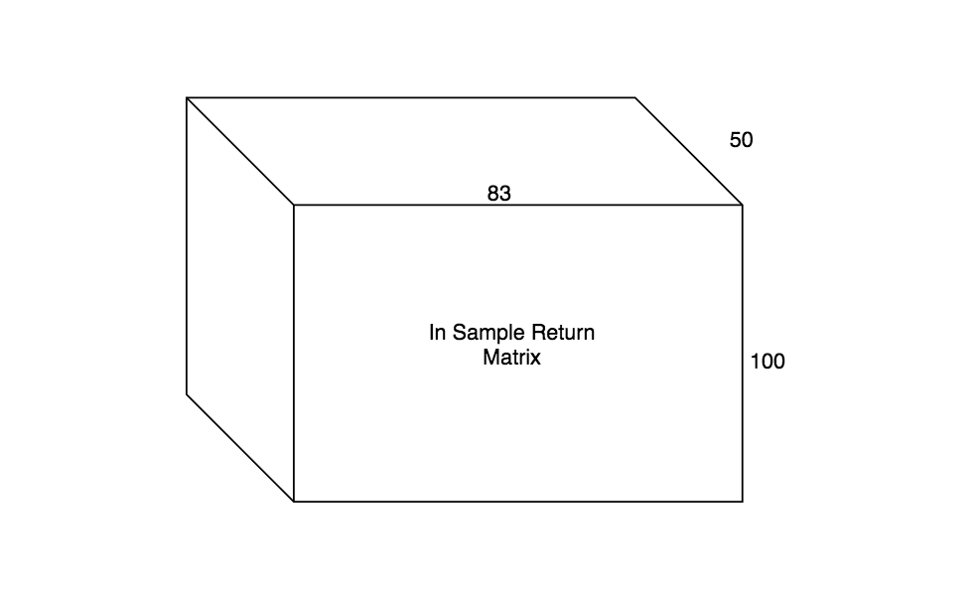

These two matrices are constructed by using two different functions, which are called inSampleRollingWindow and outOfSampleRollingWindow. These two functions will read in the 2D full sample return matrix and divide them into 50 2D in sample return matrices and 49 2D out of sample matrices. Then I created a 2D matrix matrixOfCompanyMeanReturn, which stores the mean return of the companies in each of the rolling windows.

Then I created 3 different classes, including Portfolio, matrixOperations and statisticalOperations. Portfolio calls the other 2 classes, but they are 3 different classes, not inheritances. For both matrixoOperations and statisticalOperations, all the public variables inside these two classes are static, therefore we can share its functionality within all of the objects. These two classes include all the calculations require for this project.

Then I started to construct portfolios with different returns and different time periods. In total, I created 21 portfolios (from 0% to 10% with an increment of 0.5%) for 50 different periods, with the product of 1050 portfolios. And the diagram below can show the structures and variables of the portfolio.

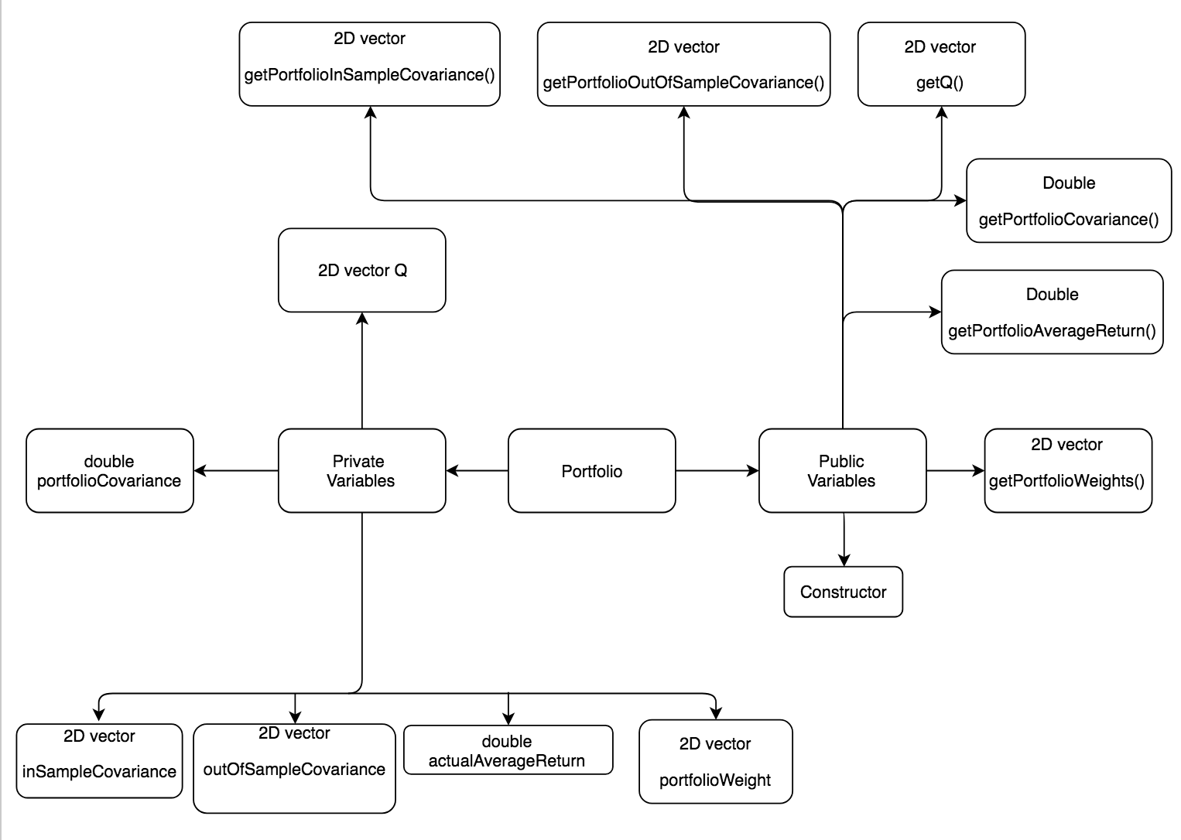

Then I use the call functions to obtain the out of sample portfolio average return and covariance and save them into 2D matrices (oosAverageReturn and oosCovariance respectively). Therefore these two matrices are our final results for this project and next part will be evaluation of our results.

**Evaluation**

The table below shows the average out of sample return from different portfolio targets (i.e. mean return over 50 out of sample average returns):

|  |  |  |  |  |  |  |  |  |  |  |  |
| --- | --- | --- | --- | --- | --- | --- | --- | --- | --- | --- | --- |
| **Target Return** | **0%** | **0.50%** | **1%** | **1.50%** | **2%** | **2.50%** | **3%** | **3.50%** | **4%** | **4.50%** | **5%** |
| **Average Return** | 0.1330% | 0.2391% | 0.3510% | 0.4466% | 0.5199% | 0.5211% | 0.5993% | 0.7827% | 0.8701% | 0.9142% | 1.0195% |
| **Target Return** | **5.50%** | **6%** | **6.50%** | **7%** | **7.50%** | **8%** | **8.50%** | **9%** | **9.50%** | **10%** |  |
| **Average Return** | 1.0368% | 1.0733% | 1.1956% | 1.2118% | 1.2916% | 1.3734% | 1.4522% | 1.5314% | 1.5223% | 1.5820% |  |

As we can see in on the table above, as the target return increases, the out of sample average return will also increase. And the diagram below shows the changes of out of sample returns in different periods, we can see that the portfolio return fluctuates over the 50 periods of rolling windows, where the largest loss is about 16% and largest gain is about 18% for 10% target return. Only the first period has 10% return out of sample, therefore we can see that the out of sample performance of the Markowitz model is not very consistent.

The table below shows the standard deviation of the out of sample average return of the 21 portfolios over 50 rolling windows:

|  |  |  |  |  |  |  |  |  |  |  |  |
| --- | --- | --- | --- | --- | --- | --- | --- | --- | --- | --- | --- |
| **Target Return** | **0.00%** | **0.50%** | **1.00%** | **1.50%** | **2.00%** | **2.50%** | **3.00%** | **3.50%** | **4.00%** | **4.50%** | **5.00%** |
| **Standard Deviation** | 0.4768% | 0.5113% | 0.6308% | 0.8542% | 1.1048% | 1.3603% | 1.6758% | 1.9948% | 2.3172% | 2.6911% | 3.0628% |
| **Target Return** | **5.50%** | **6.00%** | **6.50%** | **7.00%** | **7.50%** | **8.00%** | **8.50%** | **9.00%** | **9.50%** | **10.00%** |  |
| **Standard Deviation** | 3.4089% | 3.6533% | 4.0247% | 4.3110% | 4.6953% | 5.0432% | 5.3556% | 5.7711% | 6.3423% | 6.8094% |  |

The diagram above shows the portfolio out of sample covariance (variance) over different rolling windows. We can see that the out of sample variance of the portfolio increases when the loss of the portfolio increases and vice versa. We can also see that the higher the target return, out of sample portfolio variance can also be higher.

In my opinion, the Markowitz model does not perform very well. As we can see, even we set the target return to be 10%, but the average return for all out of sample periods is about 1.5% and the fluctuation of the return in the back-test is huge. There are only 8 out of 50 out of sample returns are close to or above 10% for 10% target return. Therefore I think we can consider alternative models to optimize the return.

Note. Csv files for portfolio returns and portfolio variances can be found by running the code, and also attached with the zip file. If you would like to ensure the csv file is correct, please run the following command for final result. The result will be a 21 x 50 matrix, so rows represent portfolios with different target return and columns represent portfolios in different out of sample periods.

g++ -o portfolio mainwo.cpp portfolio.cp csv.cp matrixOperations.cpp statisticalOperations.cpp